Module 11 – EOQ

Exploratory Data Analysis

* *Make line graphs showing the following data over time:*

*Figure 1: Sales over time*

*Figure 2: Unit Purchase Cost over time*

*Figure 3: Fixed Order Cost over time*

*Different forecasting methods to determine annual demand for 2025 to use for our model*

* + *Naïves Demand: 16654 ( Used for stipulation)*
  + *Weighted Moving Average Demand: 23416*
  + *Linear Regression Demand: 23803*
  + *Exponential Smoothing Demand: 23826*
* *Unit per cost and cost per order were simply kept $35 and $50*

Model Formulation

1. *Decision Variables  
   Decision variables are the variables in an optimization model whose values are to be determined in order to achieve the best outcome according to the objective function. These variables represent the decisions to be made within the constraints of the problem.*

*In this model “Order quantity” and Min” = $C$9 is Decision Variables*

1. *Objective Function  
   The objective function is a mathematical expression that defines the goal of the optimization model. It is formulated in terms of the decision variables and is either maximized or minimized, depending on the nature of the problem.*

*Objective Function, “Total Cost” Min, =$C$14*

1. *Constraints  
   Constraints are mathematical expressions that represent the limitations or requirements of the optimization problem. They define the feasible region by restricting the values that the decision variables can take.*

*In the model the following Constraints are given:*

*$C$9 = Integer*

*$C$9 >= 1*

1. *Order quantity should be integers*
2. *Order quantity should be greater than or equal 1*

Model Optimized for Minimizing Costs with Optimal Order Quantity

*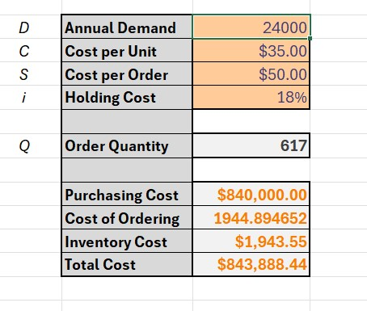*

*Figure 4: Screenshot of the model*

*The model is recommending an order quantity of 617 for an annual demand of 24000 at $35 cost per unit, $50 cost per order at a holding cost of 18%.*

*Figure 5: Sawtooth chart for 2025*

Model with Stipulation

*Figure 6: Stepulated model*

*Lastly, do the following:*

* *Planned backorders are included in the EOQ model when it is cheaper to temporarily delay some customer orders than to hold excess inventory. This reduces holding and ordering costs, especially when customers are willing to wait and the shortage cost is lower than carrying cost.*
* *Since the Order quantity is same as in the original model the graph is the same as figure 5.*